**Quiz: Another Experiment**

**URL to the quiz**: [Quiz: Another experiment | Watch and Code](https://watchandcode.com/courses/350615/lectures/23117859)

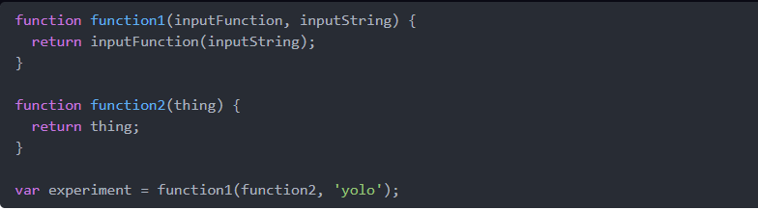

Statement – True/False XX%

Evidence

Which of the following statements are true?

1. experiment will be equal to 'yolo'
   1. True, 100%
2. When function1 runs, inputFunction will be equal to function2
   1. True, 100%
3. When function1 runs, inputString will be equal to 'yolo'
   1. True, 100%
4. When function2 runs, thing will be equal to 'yolo'
   1. True, 100%
5. function2 will run twice
   1. False, 100%
6. function2 will run once
   1. True, 100%